Global Events, Commodities & Currency Markets: Market Trends, Investment Risk & Global Economic Insights
Prepared By:
Group 6 | ECTS : 120 B
Department:
Department of Business Analytics
MSc Data Science
Organization:
University of Europe for Applied Sciences (UE)
In collaboration with Avron Global Ltd

Executive Summary
Purpose
This report presents a comprehensive market research and business analytics study of Brent Crude Oil, Gold, Silver, and global currency markets from 1960 to 2026. The objective is to examine how major geopolitical events, economic crises, monetary policy changes, and supply disruptions influence commodity prices and international payment systems. Historical data from the World Bank Commodity Markets (Pink Sheet) and the SWIFT RMB Tracker were analysed using Python-based statistical and visualization techniques, including trend analysis, correlation analysis, moving averages, volatility analysis, and comparative event analysis.
Key Insights
The analysis found that Brent Crude Oil is the most sensitive commodity to geopolitical conflicts and supply-side disruptions, showing significant price volatility during events such as the 1973 Oil Embargo, the 2008 Global Financial Crisis, and the Russia–Ukraine conflict. Gold consistently acted as a safe-haven asset during periods of financial uncertainty, while Silver exhibited higher price volatility due to its dual role as both an industrial and precious metal. Correlation analysis revealed a strong positive relationship between Gold and Silver prices, whereas Brent Crude Oil showed a moderate positive correlation with both metals. The study also confirmed that the US Dollar continues to dominate global payment systems, although the Chinese Renminbi has gradually expanded its international presence.
Recommendations
Based on the findings, the report recommends diversifying investment portfolios across commodities to reduce market risk, implementing commodity price hedging strategies to manage volatility, and continuously monitoring geopolitical developments that may affect global markets. Businesses should incorporate data-driven market intelligence into strategic planning to improve decision-making and risk management. In addition, organisations engaged in international trade should monitor the growing role of the Renminbi while continuing to account for the dominant position of the US Dollar in global payment systems.

Executive Summary 2
1. Introduction 5
1.1 Background 5
1.2 Research Objectives 5
General Objective 5
Specific Objectives 6
1.3 Scope of the Study 6
2. Data and Methodology 7
2.1 Data Sources 7
2.2 Data Preprocessing 8
2.3 Methodology 9
2.4 Project Management (SCRUM Framework) 9
2.5 Assumptions 11
3. Analysis and Insights 12
3.1 Commodity Price Trends 12
3.2 Impact of Major Global Events on Commodity Prices 14
3.3 Comparative Analysis of Commodity Prices 15
3.4 Correlation Analysis of Commodity Prices 17
3.5 Volatility Analysis 20
3.6 Global Currency Market Analysis 21
3.6.1 Global Payment Currency Share 21
3.6.2 Global Foreign Exchange (Forex) Market Share / Trading Volume 22
3.6.3 Global Foreign Exchange Reserves Composition 24
3.7 Major Global Events Affecting Commodity and Currency Markets 25
3.8 Impact of Major Global Events on Brent Crude Oil 26
3.9 Gold as a Safe-Haven Asset During Economic Uncertainty 27
3.10 Silver: Industrial Commodity and Investment Asset 27
3.11 Currency Market Interpretation 28
3.12 Business Risks Assessments and Market Implications 29
4. Recommendations 30
1. Diversify Investment Portfolios 30
2. Strengthen Commodity and Currency Risk Management 30
3. Continuously Monitor Global Economic and Geopolitical Developments 30
4. Adopt Data-Driven Decision-Making 31
5. Promote Currency Diversification in International Trade 31
5. Conclusion 31
6. Appendices 32
Appendix A – Data Visualisations 32
Appendix B – Technical Details 34
Appendix C – Glossary 36
7. References 37

Introduction

1.1 Background
Commodity markets play a vital role in the global economy by influencing international trade, industrial production, investment decisions, and economic stability. Among the most important commodities, Brent Crude Oil, Gold, and Silver are widely traded and serve different economic purposes. Their prices are affected by factors such as global supply and demand, geopolitical conflicts, inflation, monetary policies, and financial market conditions. As a result, analysing their long-term price movements provides valuable insights into market behaviour and economic trends.
Brent Crude Oil is one of the world's primary benchmarks for crude oil pricing and significantly influences global energy costs. Changes in oil prices directly impact transportation, manufacturing, and overall economic activity. Historical events such as the 1973 OPEC Oil Embargo, the 2008 Global Financial Crisis, and the Russia–Ukraine conflict have demonstrated how geopolitical disruptions can lead to substantial fluctuations in oil prices.
Gold is widely recognised as a safe-haven asset that investors prefer during periods of economic uncertainty and market volatility. In contrast, Silver serves both as a precious metal and an industrial commodity, making its price more volatile due to the combined influence of investment demand and industrial consumption.
Alongside commodity markets, international payment systems continue to evolve. The United States Dollar (USD) remains the dominant global reserve and trading currency, while the Chinese Renminbi (RMB) has gradually expanded its role in international trade. Understanding the relationship between commodity markets and global payment trends is increasingly important in today's interconnected economy.
This study analyses historical monthly data from 1960 to 2026 to examine commodity price movements, assess the impact of major global events, evaluate relationships among Brent Crude Oil, Gold, and Silver, and explore recent developments in international currency markets. The findings provide valuable insights for investors, businesses, and policymakers seeking to make informed decisions in a dynamic global environment.

1.2 Research Objectives

General Objective
The primary objective of this study is to analyse the long-term behaviour of Brent Crude Oil, Gold, Silver, and global currency markets, and to evaluate the impact of major geopolitical and economic events on commodity prices and international payment systems using historical data from 1960 to 2026.

Specific Objectives
- To examine the historical price trends of Brent Crude Oil, Gold, and Silver over the period from 1960 to 2026.
- To analyse the impact of major global events, including geopolitical conflicts, economic crises, and monetary policy changes, on commodity price movements.
- To evaluate the relationship and correlation between Brent Crude Oil, Gold, and Silver using statistical analysis.
- To compare the performance and volatility of commodities during different periods of market uncertainty and financial crises.
- To examine the changing roles of the United States Dollar (USD) and the Chinese Renminbi (RMB) in global payment systems.
- To provide data-driven recommendations that support investment decisions, business risk management, and strategic planning.

1.3 Scope of the Study
This study focuses on analysing the long-term behaviour of Brent Crude Oil, Gold, Silver, and selected global currency markets using historical monthly data from January 1960 to April 2026. Commodity price data were obtained from the World Bank Commodity Markets (Pink Sheet), while international payment data were sourced from the SWIFT RMB Tracker. The analysis includes data preprocessing, trend analysis, moving averages, correlation analysis, volatility analysis, crisis comparison, and currency market assessment to understand the influence of major global events on commodity prices and international payment systems.
The study is limited to the selected commodities and currency indicators included in the available datasets. While the report identifies historical trends and relationships, it does not attempt to predict future market prices using advanced forecasting or machine learning models. The findings are intended to provide valuable insights for investors, businesses, researchers, and policymakers by supporting informed decision-making and effective risk management in global financial markets.

Data and Methodology

2.1 Data Sources
This study uses historical commodity price data and international payment statistics collected from reliable and internationally recognised sources. Historical monthly price data for Brent Crude Oil, Gold, and Silver were obtained from the World Bank Commodity Markets (Pink Sheet) database, which provides comprehensive information on global commodity prices over an extended period. To analyse trends in international payment systems and currency dominance, data were collected from the SWIFT RMB Tracker, which publishes monthly reports on global payment market shares and the international usage of major currencies.
The commodity datasets cover the period from January 1960 to April 2026, with each cleaned dataset containing 796 monthly observations. To support time-series analysis, additional variables such as Year, Month, Month Name, Quarter, Year-Month, Percentage Change, and Moving Average (for Gold and Silver) were created during the preprocessing stage. The currency analysis is based on the most recent SWIFT payment reports available during the study period. These data sources were selected because they are internationally recognised, regularly updated, and widely used in academic research and economic analysis, making them suitable for investigating long-term commodity price behaviour and global payment trends.

Dataset | Source | Time Period | Frequency | Records | Variables
Brent Crude Oil | World Bank Commodity Markets (Pink Sheet) | January 1960 – April 2026 | Monthly | 796 | 8
Gold | World Bank Commodity Markets (Pink Sheet) | January 1960 – April 2026 | Monthly | 796 | 8
Silver | World Bank Commodity Markets (Pink Sheet) | January 1960 – April 2026 | Monthly | 796 | 8
Global Currency Tracker (USD/RMB) | SWIFT RMB Tracker | 2025 – 2026* | Monthly Reports | Multiple monthly reports | Multiple variables
Table 1:- Dataset Summary

Variable | Description
Date | Monthly observation date
Price | Commodity price in US Dollars (USD)
Year | Year extracted from the Date field
Month | Numeric month (1–12)
Month Name | Name of the month
Quarter | Calendar quarter (Q1–Q4) (Brent dataset)
Year-Month | Combined Year and Month identifier
% Change | Monthly percentage change in price
Moving Average | Three-month moving average (Gold and Silver datasets only)
Table 2: Variables in the Cleaned Commodity Datasets

2.2 Data Preprocessing
Before conducting the analysis, the collected datasets were carefully preprocessed to ensure data quality, consistency, and suitability for time-series analysis. Each commodity dataset was examined for missing values, duplicate records, and inconsistencies in the data. The inspection confirmed that the cleaned datasets contained no missing values or duplicate entries, allowing the analysis to proceed without the need for data imputation or record removal.
The Date column was converted into a standard datetime format to facilitate chronological analysis. Additional time-based variables, including Year, Month, Month Name, Quarter (for the Brent dataset), and Year-Month, were created to support annual, quarterly, and monthly trend analysis. These engineered features enabled the comparison of commodity prices across different time periods and simplified the visualisation of long-term market trends.
To better understand price fluctuations, the monthly percentage change (% Change) was calculated for all three commodity datasets. Furthermore, a three-month moving average was computed for the Gold and Silver datasets to smooth short-term price fluctuations and highlight underlying long-term trends. Annual average prices were also generated to facilitate year-on-year comparisons and evaluate the impact of major geopolitical and economic events.
Since all commodity prices obtained from the World Bank Commodity Markets (Pink Sheet) were reported in United States Dollars (USD), no additional currency normalisation was required. This ensured consistency when comparing Brent Crude Oil, Gold, and Silver prices across the study period. The preprocessed datasets formed the foundation for subsequent trend analysis, correlation analysis, volatility assessment, and event-based comparisons presented in this report.

2.3 Methodology
This study adopts a quantitative research methodology based on historical time-series data to examine long-term commodity price movements and global payment trends. A combination of statistical analysis and data visualisation techniques was employed to identify trends, relationships, and the impact of major geopolitical and economic events on commodity markets.
The following analytical techniques were applied throughout the study:
- Trend Analysis: Used to examine the long-term price movements of Brent Crude Oil, Gold, and Silver and identify significant changes over the study period.
- Comparative Analysis: Conducted to compare commodity performance during major global events, including the 1973 OPEC Oil Embargo, the 2008 Global Financial Crisis, the COVID-19 pandemic, and the Russia–Ukraine conflict.
- Correlation Analysis: Pearson correlation analysis was performed to measure the strength and direction of relationships among Brent Crude Oil, Gold, and Silver prices.
- Moving Average Analysis: Three-month moving averages were calculated for Gold and Silver to reduce short-term fluctuations and highlight long-term trends.
- Volatility Analysis: Monthly percentage changes in commodity prices were analysed to evaluate price stability and market risk over time.
- Currency Market Analysis: SWIFT payment data were examined to assess the global payment shares of the United States Dollar (USD) and the Chinese Renminbi (RMB), providing insights into changing international payment trends.
Data processing and analysis were carried out using Python within the Kaggle Notebook environment. The Pandas library was used for data cleaning, transformation, and statistical analysis, while Matplotlib was used to create visualisations that supported trend interpretation and comparative analysis. Microsoft Excel was used for data verification and presentation formatting, ensuring the accuracy and consistency of the reported findings.

2.4 Project Management (SCRUM Framework)
The project was managed using the Agile SCRUM methodology, which provided a structured and iterative approach to planning, executing, and monitoring project activities. SCRUM was selected because it promotes collaboration, continuous progress tracking, and efficient task management throughout the project lifecycle.
To support project execution, Jira Software was used as the project management tool. The project was organized into epics representing the major phases of work, while individual tasks were created for specific deliverables within each phase. Story points were assigned to estimate the relative effort required for each task, enabling effective workload distribution and progress monitoring.
Regular tracking of task completion and project milestones ensured that activities remained aligned with the planned schedule. The Agile approach also allowed the team to manage parallel activities efficiently, particularly during the analytical and visualization stages of the project, resulting in timely completion of all deliverables.
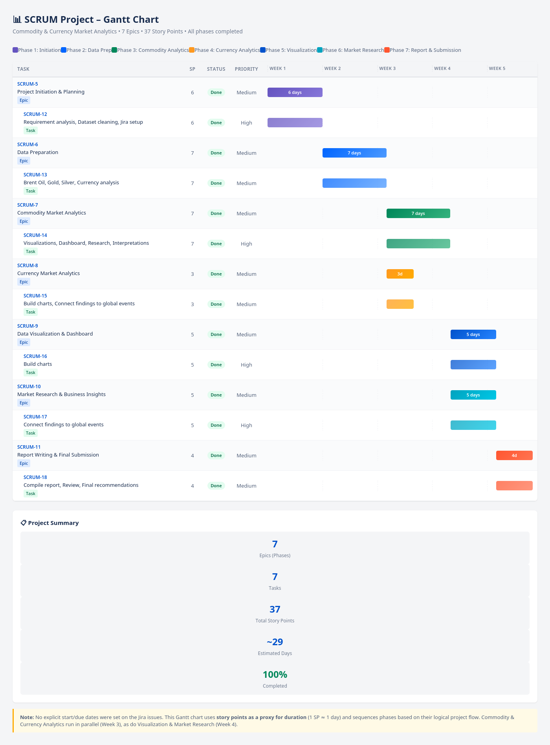
Figure 1 : Project Gantt Chart
Project Timeline
Figure 5.1 presents the overall project timeline generated using Jira Software. The Gantt chart illustrates the sequence of project activities from project initiation through final report submission, covering seven major phases: Project Initiation and Planning, Data Preparation, Commodity Market Analytics, Currency Market Analytics, Data Visualization and Dashboard Development, Market Research and Business Insights, and Report Writing and Final Submission.
The timeline demonstrates the logical progression of project activities while highlighting parallel execution where appropriate. Commodity Market Analytics and Currency Market Analytics were conducted simultaneously to improve efficiency, followed by parallel development of dashboards and market research activities. This structured scheduling enabled effective resource utilization, continuous progress monitoring, and successful completion of the project within the planned timeframe.

2.5 Assumptions
The analysis presented in this study is based on the following assumptions:
- Historical commodity price data obtained from the World Bank Commodity Markets (Pink Sheet) are accurate, complete, and representative of global market conditions throughout the study period.
- Payment market share data published by the SWIFT RMB Tracker accurately reflect international payment trends and currency usage during the reporting period.
- All commodity prices are reported in United States Dollars (USD), ensuring consistent comparisons across Brent Crude Oil, Gold, and Silver without requiring additional currency conversion.
- Major geopolitical and economic events considered in this study had a measurable influence on commodity price movements and international payment systems.
- The analytical techniques employed, including trend analysis, correlation analysis, moving averages, volatility analysis, and comparative analysis, are sufficient to identify meaningful long-term patterns and relationships within the selected datasets.

Analysis and Insights

3.1 Commodity Price Trends
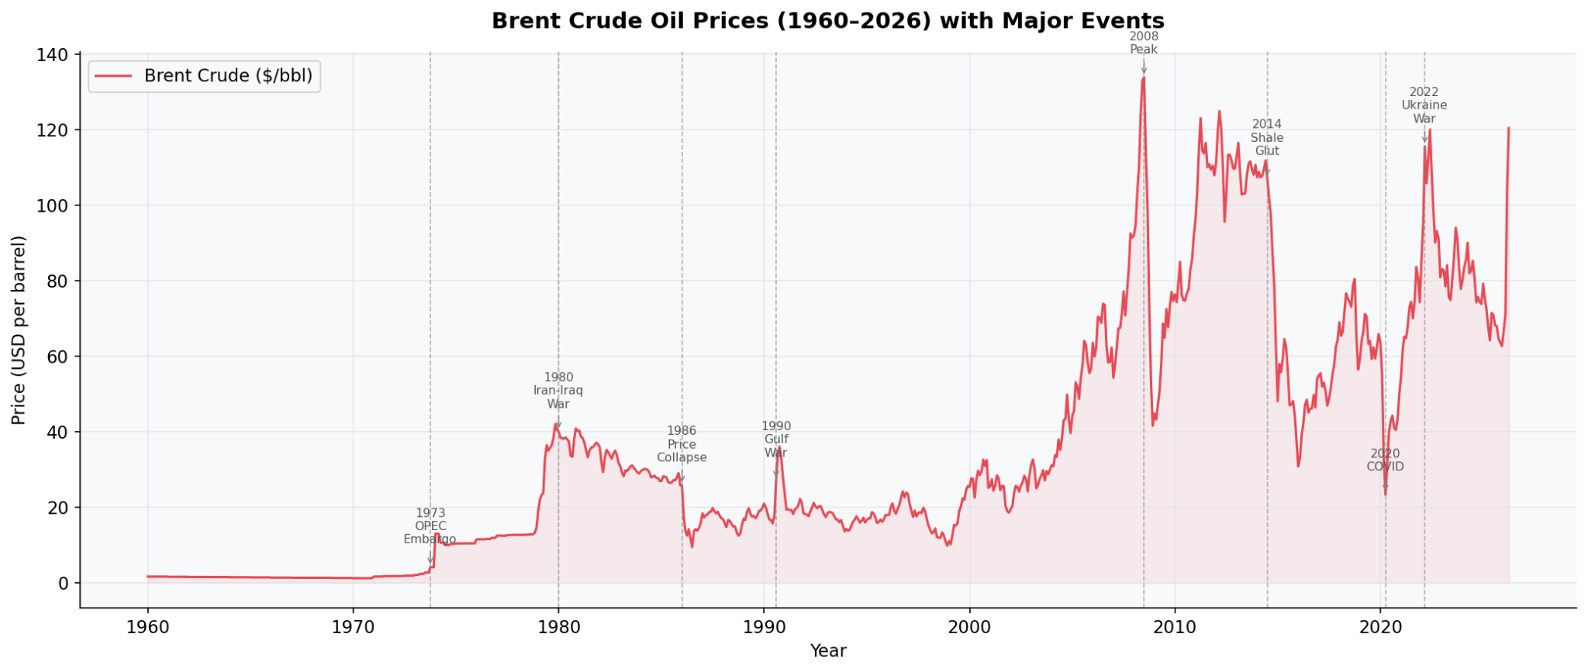
Figure 2: Brent Crude Oil Prices (1960–2026) with Major Events
The historical trend of Brent crude oil prices demonstrates that oil markets are highly sensitive to geopolitical events, supply disruptions, and global economic conditions. Between 1960 and the early 1970s, oil prices remained relatively stable due to abundant supply and relatively low geopolitical tensions. However, the 1973 OPEC oil embargo marked the first major structural shift, causing prices to rise sharply as oil-exporting countries restricted production.
Further significant price increases occurred during the Iran-Iraq War (1980), the Gulf War (1990), and the commodity boom preceding the 2008 Global Financial Crisis, when Brent crude reached its historical peak of approximately USD 133.87 per barrel. During the COVID-19 pandemic in 2020, global demand collapsed because of lockdowns and travel restrictions, resulting in one of the steepest declines in oil prices. Prices recovered rapidly after economic reopening and increased further following the Russia–Ukraine conflict in 2022 due to sanctions and supply disruptions.
Key Insight
Brent crude oil is the most event-sensitive commodity among the three analysed commodities, responding immediately to geopolitical and supply-side shocks.
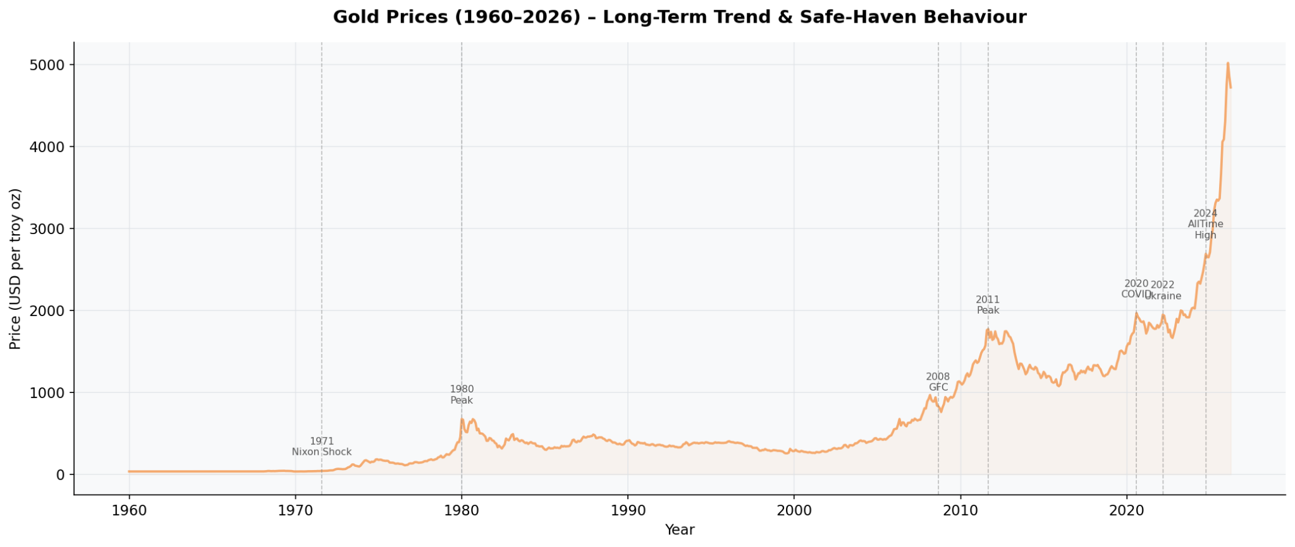
Figure 3 : Gold Prices (1960–2026)
Unlike crude oil, gold exhibited a steady long-term upward trend throughout the study period. After the collapse of the Bretton Woods system in 1971, gold prices were no longer fixed to the US dollar and began responding to market forces. The first major rally occurred in 1980 due to inflationary pressures and global political uncertainty.
During the Global Financial Crisis of 2008, investors increasingly viewed gold as a safe-haven asset, resulting in sustained price growth. Additional increases occurred during the COVID-19 pandemic and geopolitical tensions in 2022. By 2026, gold reached its highest historical value of approximately USD 5,019.97 per ounce, highlighting its long-term appreciation and its role as a hedge against uncertainty.
Key Insight
Gold demonstrates consistent long-term growth and provides stability during periods of financial and geopolitical instability.

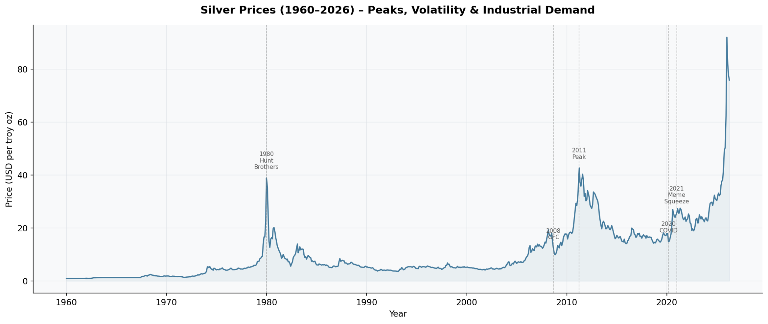
Figure 4 : Silver Prices (1960–2026)
Silver prices exhibit significantly greater volatility than gold because silver serves both as a precious metal and an industrial commodity. The largest historical spike occurred in 1980 during the Hunt Brothers silver squeeze, followed by another substantial increase during the commodity boom of 2011.
Industrial demand, particularly from electronics, renewable energy technologies, and solar panel manufacturing, contributes to silver's price fluctuations. During periods of economic expansion, silver generally performs strongly, whereas recessions cause sharper declines compared with gold.
Key Insight
Silver combines characteristics of both investment and industrial commodities, making it more volatile than gold while maintaining a strong long-term relationship with precious metal markets.

Commodity | Highest Price (Year) | Lowest Price (Year) | Average Price
Brent Crude Oil | USD 133.87 (2008) | USD 1.21 (1970) | USD 35.04
Gold | USD 5,019.97 (2026) | USD 34.94 (1970) | USD 645.52
Silver | USD 92.06 (2026) | USD 0.91 (1960) | USD 10.23
Table 3 : Highest, Lowest and Average Commodity Prices (1960–2026)
Table 6.1 provides a summary of the highest, lowest, and average prices recorded for Brent Crude Oil, Gold, and Silver during the study period. Brent Crude Oil reached its highest price of USD 133.87 per barrel in 2008, reflecting the impact of strong global demand and geopolitical tensions, while its lowest price of USD 1.21 per barrel was recorded in 1970. Gold achieved the highest value among all commodities, reaching USD 5,019.97 per ounce in 2026, highlighting its sustained long-term appreciation and safe-haven characteristics. Silver recorded a peak price of USD 92.06 per ounce in 2026, whereas its lowest value of USD 0.91 per ounce occurred in 1960. These findings demonstrate the differing growth patterns and volatility levels across the three commodities over the 66-year study period.

3.2 Impact of Major Global Events on Commodity Prices

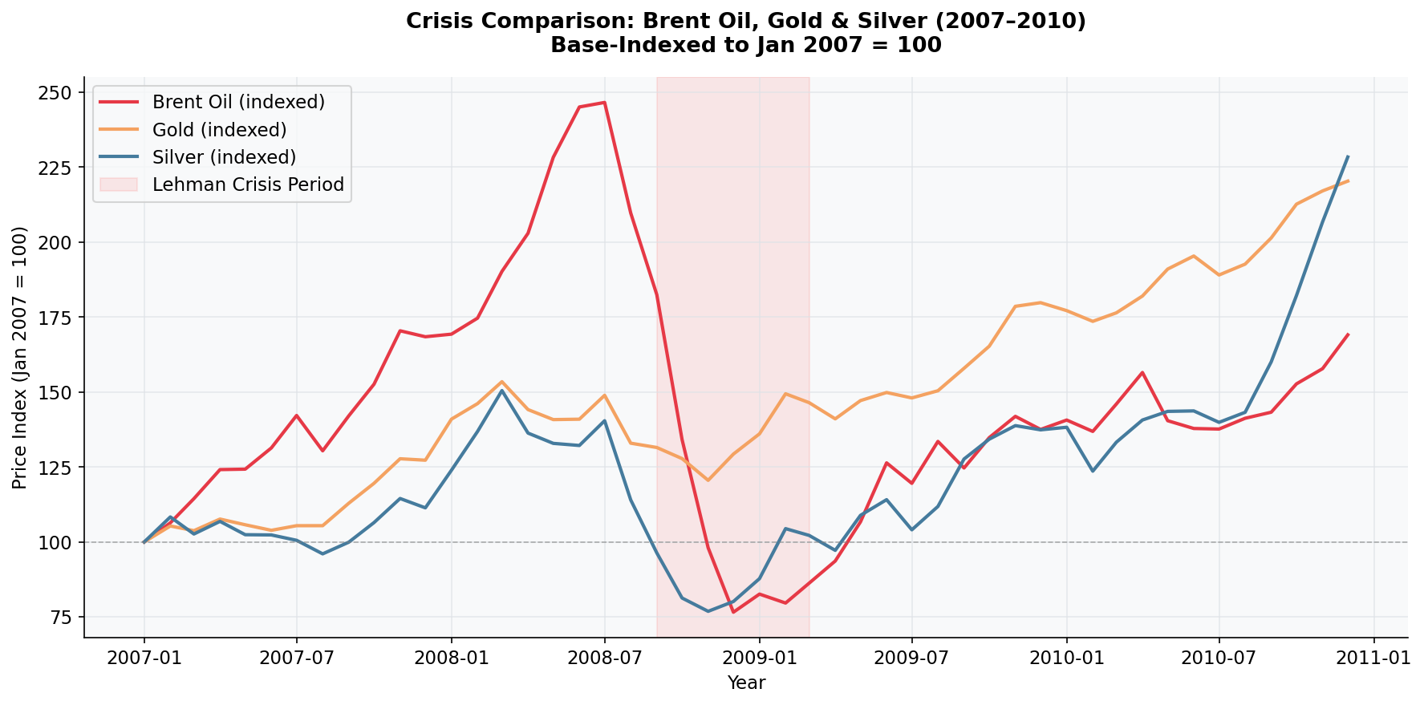
Figure 5 : Commodity Price Comparison During Major Global Events
Commodity markets are highly influenced by geopolitical conflicts, economic crises, and global supply–demand imbalances. Figure 4 illustrates how Brent Crude Oil, Gold, and Silver responded during major global events, highlighting the different behaviour of each commodity under changing market conditions.
Brent Crude Oil experienced the largest price fluctuations during global crises due to disruptions in energy supply and changes in global demand. Events such as the 2008 Global Financial Crisis caused a sharp decline in oil prices as industrial activity and transportation slowed worldwide. During the COVID-19 pandemic, reduced travel and economic restrictions further weakened oil demand, resulting in another significant price drop. In contrast, the Russia–Ukraine conflict disrupted global energy supplies, leading to a rapid recovery and substantial increase in Brent crude oil prices.
Gold displayed relatively stable performance throughout these periods and recorded strong price appreciation during times of economic uncertainty. As investors sought safer assets during financial market instability, gold prices increased steadily, reinforcing its role as a traditional safe-haven investment. Silver followed a similar trend but exhibited greater price fluctuations because its value is influenced by both investment demand and industrial consumption.
Overall, the analysis demonstrates that Brent Crude Oil is the most sensitive commodity to geopolitical and supply-side shocks, while Gold provides greater stability during periods of financial uncertainty. Silver exhibits characteristics of both commodities, responding to investor sentiment as well as changes in industrial demand. These findings emphasise the importance of monitoring global events when evaluating commodity market performance and developing investment or risk management strategies (World Bank, 2025; World Gold Council, 2024).

3.3 Comparative Analysis of Commodity Prices
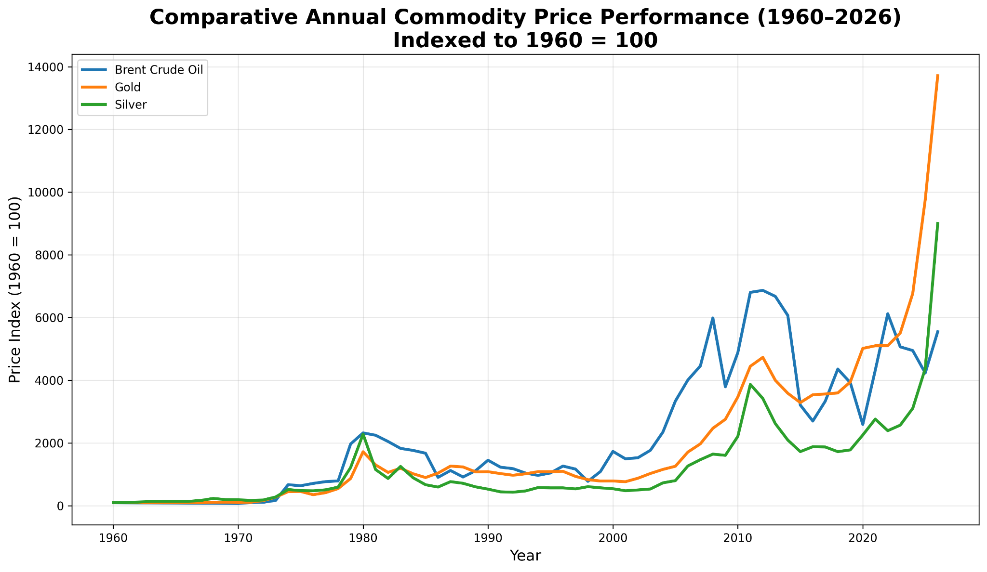
Figure 6 : Annual Average Prices of Brent Crude Oil, Gold, and Silver (1960–2026)
The annual average price comparison highlights the distinct long-term behaviour of Brent Crude Oil, Gold, and Silver over the study period. Although all three commodities exhibited overall price growth between 1960 and 2026, the magnitude and consistency of their movements differed considerably.
Brent Crude Oil experienced the most pronounced fluctuations, with prices responding rapidly to geopolitical conflicts, production decisions, and global economic conditions. Significant increases were observed during the oil crises of the 1970s, the commodity boom preceding the 2008 Global Financial Crisis, and the Russia–Ukraine conflict. These fluctuations demonstrate the strong dependence of oil prices on global supply and demand dynamics.
Gold showed the most consistent long-term appreciation, particularly after the 1970s when the gold standard ended. Its steady upward trend reflects its role as a safe-haven asset during periods of inflation, financial uncertainty, and geopolitical instability. In contrast, silver followed a similar upward trend but exhibited greater variability because of its dual role as both a precious metal and an industrial commodity. Industrial demand from sectors such as electronics and renewable energy contributed to larger price fluctuations compared with gold.
Overall, the comparative analysis indicates that gold offered the most stable long-term growth, Brent crude oil recorded the highest sensitivity to external shocks, and silver combined investment characteristics with higher market volatility. These differences demonstrate that each commodity responds differently to global economic conditions and therefore serves a distinct role within investment portfolios and commodity markets (World Bank, 2025; World Gold Council, 2024).

Year | Brent | Gold | Silver
1960 | 1.63 | 35.27 | 0.91
1975 | 10.43 | 161.03 | 4.42
1990 | 23.68 | 383.47 | 4.83
2008 | 97.64 | 871.71 | 15.00
2020 | 42.30 | 1770.25 | 20.54
2026 | 90.50 | 4837.42 | 81.94

Table 4 complements Figure 6 by presenting selected annual average prices across different periods. The data highlight the substantial long-term appreciation of gold, the pronounced cyclical behaviour of Brent crude oil, and the gradual increase in silver prices over the study period.

3.4 Correlation Analysis of Commodity Prices
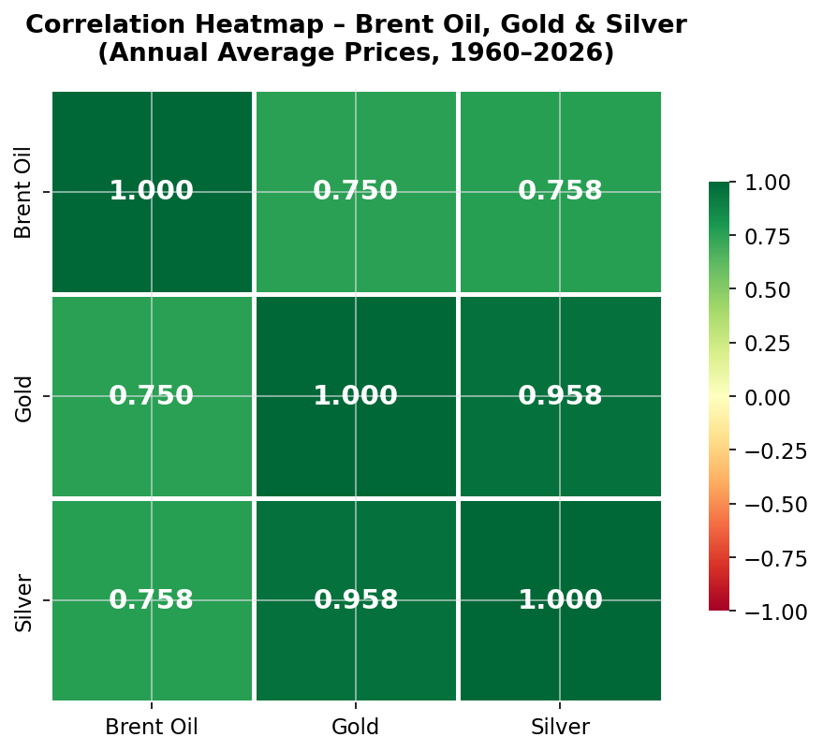
Figure 7: Correlation Heatmap of Brent Crude Oil, Gold and Silver Prices

Commodity | Brent Crude Oil | Gold | Silver
Brent Crude Oil | 1.000 | 0.750 | 0.758
Gold | 0.750 | 1.000 | 0.958
Silver | 0.758 | 0.958 | 1.000
Table 5 : Pearson Correlation Matrix of Commodity Prices

The Pearson correlation analysis was conducted to examine the relationship between the historical prices of Brent Crude Oil, Gold, and Silver over the study period. As shown in Table 5 and Figure 7, all three commodities exhibit positive correlations, indicating that their prices generally move in the same direction over the long term. However, the strength of these relationships differs across commodity pairs.
The strongest positive correlation was observed between Gold and Silver (r = 0.958), suggesting a very strong linear relationship between the two precious metals. This result indicates that changes in gold prices are often accompanied by similar movements in silver prices. The close relationship can be attributed to their shared role as investment assets, inflation hedges, and safe-haven commodities during periods of economic uncertainty.
Brent Crude Oil demonstrated a moderate positive correlation with both Gold (r = 0.750) and Silver (r = 0.758). Although oil prices are influenced primarily by geopolitical events, production levels, and global energy demand, broader macroeconomic conditions such as inflation, economic growth, and market sentiment also affect precious metal prices. Consequently, while Brent crude oil does not move as closely with gold and silver as the two metals move with each other, a positive relationship is still evident.
Overall, the correlation analysis suggests that Gold and Silver share the strongest market relationship, whereas Brent Crude Oil follows a different price pattern because of its greater sensitivity to energy market dynamics and supply-side disruptions. These findings indicate that combining energy commodities with precious metals may provide diversification benefits for investors and portfolio managers.
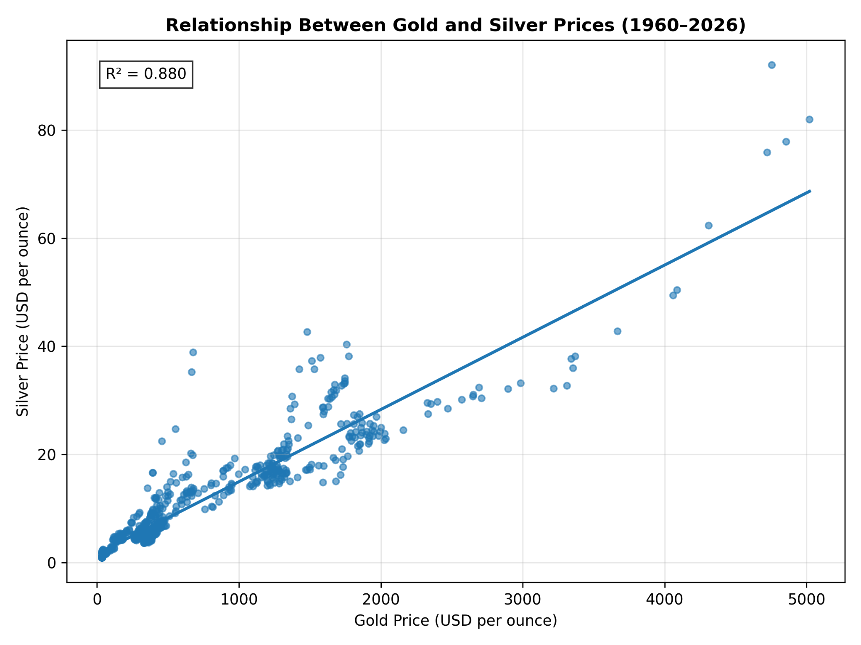
Figure 8 : Relationship Between Gold and Silver Prices (1960-2026)
Figure 8 illustrates the relationship between monthly gold and silver prices over the period 1960–2026. The scatter plot shows a clear upward trend, indicating that increases in gold prices are generally associated with increases in silver prices. The fitted regression line further confirms this positive linear relationship. The coefficient of determination (R² = 0.880) suggests that approximately 88.0% of the variation in silver prices can be explained by movements in gold prices. Although both commodities generally move together, the dispersion of points around the regression line indicates that silver experiences greater price variability due to its dual role as both an investment asset and an industrial metal. These findings support the strong correlation identified in the Pearson correlation analysis.

3.5 Volatility Analysis
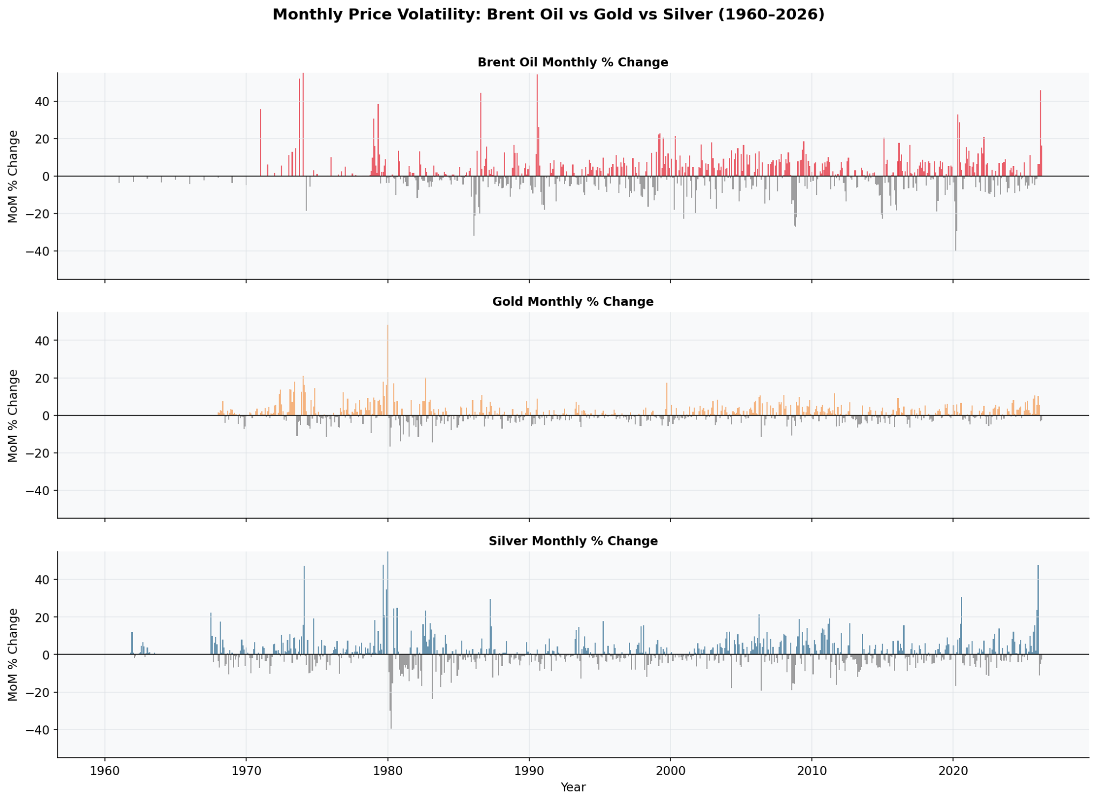
Figure 9 : Volatility Comparison of Brent Crude Oil, Gold, and Silver
Volatility analysis was conducted to evaluate the level of price fluctuations exhibited by Brent Crude Oil, Gold, and Silver throughout the study period. Price volatility is an important indicator of investment risk, as commodities with greater fluctuations generally carry higher uncertainty for investors and market participants.
As illustrated in Figure 9, Brent Crude Oil experienced the highest level of volatility among the three commodities. Oil prices were highly sensitive to geopolitical conflicts, production decisions by OPEC, supply chain disruptions, and changes in global demand. Significant fluctuations were observed during the oil crises of the 1970s, the 2008 Global Financial Crisis, the COVID-19 pandemic, and the Russia–Ukraine conflict.
Gold displayed comparatively lower volatility despite its substantial long-term price appreciation. During periods of financial uncertainty, investors increasingly shifted towards gold as a safe-haven asset, contributing to more stable price movements relative to the other commodities. Silver exhibited moderate to high volatility because of its dual role as both an investment asset and an industrial metal. Changes in industrial demand, particularly from the electronics and renewable energy sectors, contributed to larger price fluctuations than those observed for gold.
Overall, the analysis indicates that Brent Crude Oil represents the highest-risk commodity due to its sensitivity to external shocks, while Gold remains the most stable commodity and serves as an effective hedge during periods of economic uncertainty. Silver occupies an intermediate position, offering higher growth potential than gold but with greater market risk.

3.6 Global Currency Market Analysis

3.6.1 Global Payment Currency Share

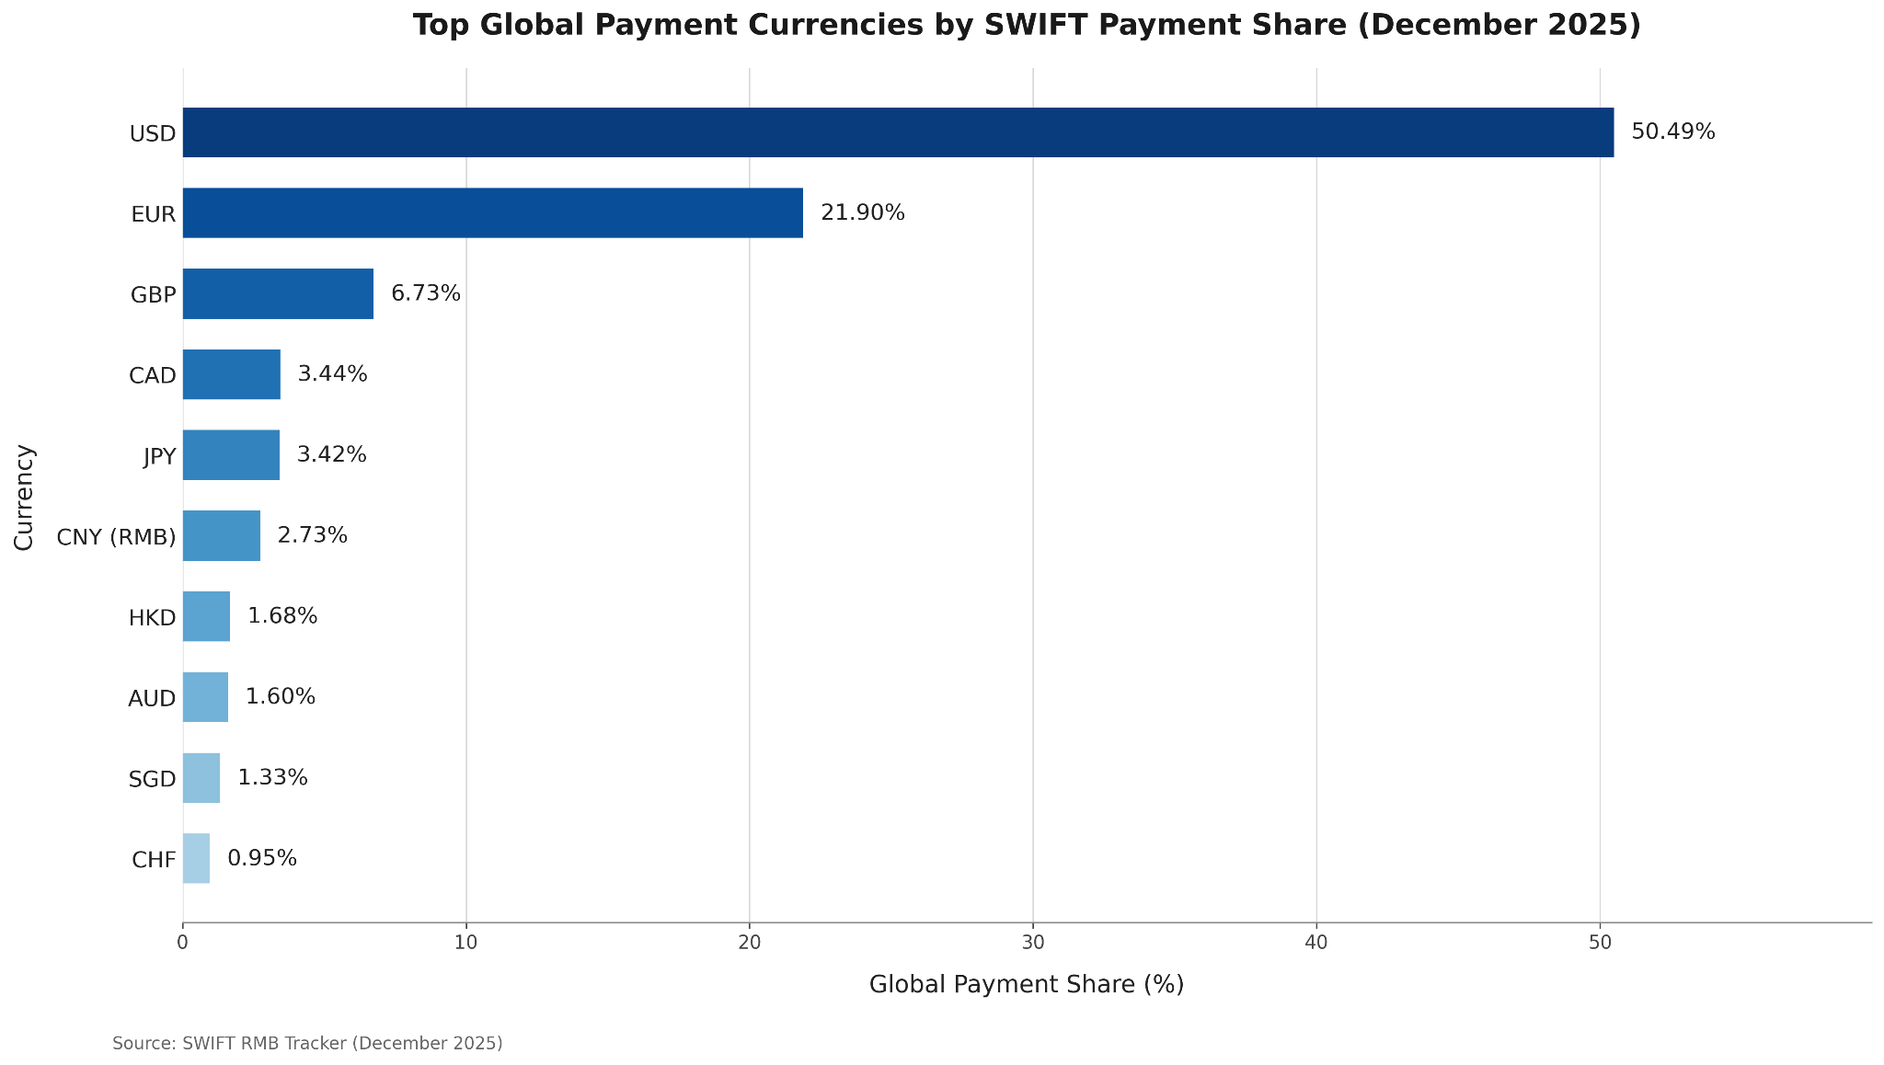
Figure 10 : Top Global Payment Currencies by SWIFT Payment Share (December 2025)

Rank | Currency | Payment Share (%) | Category
1 | USD | 50.49 | Global Reserve
2 | EUR | 21.90 | Global Reserve
3 | GBP | 6.73 | Regional
4 | CAD | 3.44 | Regional
5 | JPY | 3.42 | Regional
6 | CNY | 2.73 | Emerging
7 | HKD | 1.68 | Regional
8 | AUD | 1.60 | Regional
9 | SGD | 1.33 | Regional
10 | CHF | 0.95 | Regional
Table 6 : Global Payment Currency Share

Global payment currency share reflects the proportion of international payment transactions settled through each major currency and provides an indication of their importance within the global financial system. Figure 10 and Table 6 present the distribution of the ten most actively used currencies in international payments based on SWIFT data for December 2025.
The analysis indicates that the United States Dollar (USD) remains the dominant global payment currency, accounting for 50.49% of all international payment transactions. This overwhelming share demonstrates the continued importance of the US Dollar as the primary reserve, settlement, and invoicing currency for global trade and financial markets. The Euro (EUR) ranks second with 21.90%, maintaining a significant role in cross-border transactions, particularly within Europe and neighbouring economies.
Among the remaining currencies, the British Pound (GBP) represents 6.73% of global payments, followed by the Canadian Dollar (CAD) at 3.44% and the Japanese Yen (JPY) at 3.42%. The Chinese Yuan (CNY/RMB) accounts for 2.73%, ranking sixth globally. Although its share is considerably lower than that of the US Dollar and Euro, the RMB continues to gain international recognition as China expands its participation in global trade and promotes cross-border settlements using its domestic currency.
Currencies such as the Hong Kong Dollar (HKD), Australian Dollar (AUD), Singapore Dollar (SGD), and Swiss Franc (CHF) each contribute less than 2% of total payment volume, reflecting their more specialised regional or financial market roles. Overall, the results demonstrate that the global payment system remains highly concentrated, with the US Dollar and Euro together accounting for more than 72% of international payment activity. This concentration highlights the continued dominance of established reserve currencies, while also indicating the gradual emergence of the Chinese Yuan as an increasingly important participant in the international monetary system.

3.6.2 Global Foreign Exchange (Forex) Market Share / Trading Volume
The Foreign Exchange (Forex) market is the largest and most liquid financial market in the world, facilitating the exchange of currencies for international trade, investment, tourism, and financial transactions. According to the Bank for International Settlements (BIS) Triennial Central Bank Survey 2025, the global foreign exchange market recorded an average daily trading volume of approximately USD 9.6 trillion, reflecting the increasing integration of global financial markets and cross-border economic activities.
The U.S. Dollar (USD) continues to dominate global foreign exchange trading, accounting for 89.2% of all FX transactions. Its dominance is primarily driven by its status as the world's leading reserve currency, the preferred medium for international trade settlements, and its widespread use in commodity pricing, including oil, gold, and other major commodities.
The Euro (EUR) remains the second most actively traded currency with a market share of 28.9%, supported by the strong economic integration of the Eurozone and its importance in global trade. The Japanese Yen (JPY) and the British Pound Sterling (GBP) continue to play significant roles in international financial markets due to their high liquidity, stable economies, and active participation in global investment flows.
The Chinese Yuan (Renminbi - CNY) has continued to strengthen its position in the global foreign exchange market, accounting for 8.5% of total trading volume. This growth reflects China's expanding role in international trade, increasing cross-border settlements in Yuan, and the country's efforts to internationalize its currency.
Overall, the global foreign exchange market remains highly concentrated around a few major currencies, with developed economies accounting for the majority of trading activity. However, the gradual rise of emerging market currencies, particularly the Chinese Yuan, indicates a slow shift towards a more diversified global currency landscape.

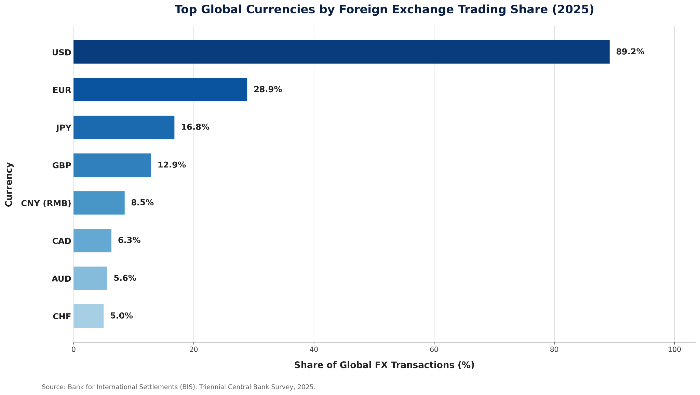
Figure 11 : Share of Global Foreign Exchange Transactions by Major Currencies (2025)

Key Insights
- The U.S. Dollar (USD) dominates the global foreign exchange market, appearing in 89.2% of all foreign exchange transactions, reinforcing its position as the world's leading trading and reserve currency.
- The Euro (EUR) is the second most actively traded currency, accounting for 28.9% of global FX transactions, supported by the strong economic integration and financial stability of the Eurozone.
- The Japanese Yen (JPY) and British Pound (GBP) continue to play significant roles in international foreign exchange markets due to their high liquidity, stable economies, and extensive participation in global financial activities.
- The Chinese Yuan (CNY) has steadily increased its presence in the global FX market, reflecting China's growing influence in international trade, cross-border investments, and currency internationalization initiatives.
- The global foreign exchange market remains highly concentrated around major developed-market currencies, highlighting their continued importance in facilitating international trade, investment, and global financial stability.

3.6.3 Global Foreign Exchange Reserves Composition
Foreign exchange reserves are assets held by central banks in foreign currencies to support monetary policy, stabilize exchange rates, facilitate international trade, and provide financial security during periods of economic uncertainty. The composition of global reserves reflects the confidence that governments and financial institutions place in major international currencies.
According to the International Monetary Fund (IMF) COFER database, the U.S. Dollar (USD) continues to dominate global foreign exchange reserves, accounting for approximately 57.7% of allocated reserves. Despite a gradual decline over the past two decades, the dollar remains the world's primary reserve currency due to its deep financial markets, liquidity, and widespread use in international trade.
The Euro (EUR) is the second-largest reserve currency with a share of around 19.8%, followed by the Japanese Yen (JPY) and British Pound Sterling (GBP). The Chinese Yuan (Renminbi) has gradually increased its share since its inclusion in the IMF's Special Drawing Rights (SDR) basket, although it still represents a relatively small proportion of global reserves.
The continued dominance of the U.S. Dollar indicates that global reserve management remains concentrated in developed-market currencies, while emerging currencies are slowly gaining recognition as international financial markets become more diversified.
Global commodity and currency markets are significantly influenced by geopolitical conflicts, economic crises, monetary policy decisions, and changes in international trade. These events affect market confidence, disrupt global supply chains, alter investor behaviour, and influence the demand and supply of commodities and currencies. Throughout the study period (1960–2026), several major global events have had a profound impact on Brent Crude Oil, Gold, Silver, and international currency markets. Understanding these events provides valuable context for interpreting the historical trends and market movements presented in the previous sections.
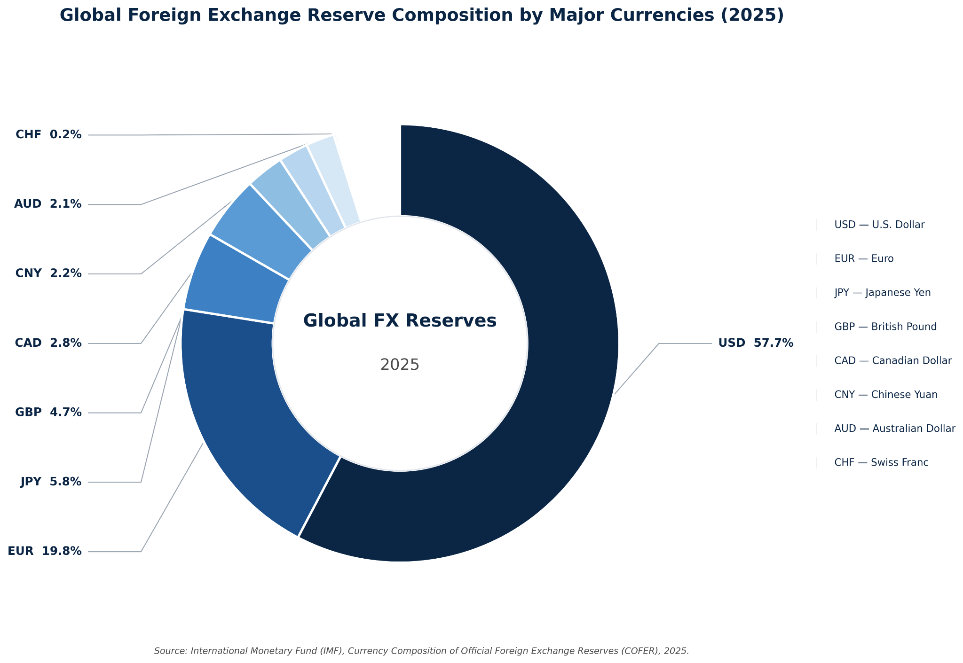
Figure 12 : Composition of Global Foreign Exchange Reserves by Major Currencies (2025).

3.7 Major Global Events Affecting Commodity and Currency Markets
Global commodity and currency markets are continuously influenced by geopolitical conflicts, economic crises, monetary policy decisions, and developments in international trade. These events affect global supply chains, investor confidence, inflation expectations, and cross-border financial activities, leading to significant fluctuations in commodity prices and currency markets. The analytical findings presented in the Brent Crude Oil Price Trends, Gold Price Trends, Silver Price Trends, and Global Currency Market Analysis demonstrate that major global events have consistently shaped market behaviour throughout the study period.
Several significant global events have had a direct impact on Brent Crude Oil, Gold, Silver, and major international currencies. These events not only influenced commodity prices but also affected foreign exchange trading, international payment systems, and central bank reserve management. Understanding these events provides important context for interpreting the trends and market movements identified in the previous analysis.

Year | Major Global Event | Impact on Commodity and Currency Markets
1973 | OPEC Oil Embargo | Reduced global oil supply, causing a sharp increase in Brent crude oil prices and contributing to worldwide inflation.
1980 | Iran–Iraq War | Declining economic activity reduced oil demand, while gold prices increased as investors sought safe-haven assets.
2008 | Global Financial Crisis | Global lockdowns caused a significant decline in oil demand, increased gold prices, and created high volatility in silver and currency markets.
2020 | COVID-19 Pandemic | Lockdowns and travel restrictions caused a historic decline in global oil demand, while gold reached record highs due to economic uncertainty. Silver experienced significant volatility because of both investment demand and reduced industrial activity.
2022 | Russia–Ukraine Conflict | Supply disruptions increased Brent crude oil prices, strengthened demand for Gold, and generated volatility across global currency markets.
2025 | Expansion of BRICS Pay and RMB Internationalisation | Increased cross-border use of local currencies supported the gradual internationalisation of the Chinese Yuan while encouraging diversification in global payment systems.
Table 7 : Major Global Events Affecting Commodity and Currency Markets
The findings presented in the Commodity Price Trends indicate that geopolitical conflicts and economic crises primarily influenced Brent Crude Oil through supply-side disruptions and changes in global energy demand. In contrast, the Gold Price Trends demonstrate that investors consistently shifted towards gold during periods of financial uncertainty, reinforcing its role as a safe-haven asset. The Silver Price Trends further reveal that silver responded to both industrial activity and investment demand, resulting in greater price volatility than gold.
Similarly, the Global Currency Market Analysis highlights that although the U.S. Dollar continues to dominate international payments, foreign exchange trading, and global reserve holdings, the Chinese Yuan (RMB) has gradually expanded its international role through increasing cross-border settlements and regional financial cooperation. These developments illustrate the growing importance of currency diversification alongside the continued dominance of established reserve currencies.
Overall, the analysis confirms that commodity and currency markets are closely interconnected with global political, economic, and financial developments. Consequently, governments, businesses, investors, and policymakers must continuously monitor geopolitical risks, macroeconomic conditions, and international trade developments to support effective risk management and informed decision-making.

3.8 Impact of Major Global Events on Brent Crude Oil
The Brent Crude Oil Price Trends analysis demonstrates that Brent crude oil prices have experienced substantial fluctuations over the study period, reflecting the sensitivity of global energy markets to geopolitical conflicts, supply disruptions, and changing economic conditions. As one of the world's primary crude oil benchmarks, Brent prices respond rapidly to changes in global supply and demand, making it one of the most volatile commodities analysed in this study.
The historical price trends indicate that geopolitical events have consistently influenced Brent crude oil prices. The 1973 OPEC Oil Embargo significantly reduced global oil supply, resulting in sharp price increases and widespread inflation. Similarly, the Russia–Ukraine conflict (2022) disrupted global energy supply chains through sanctions and trade restrictions, increasing uncertainty in international oil markets and driving Brent crude oil prices upward.
The Brent Crude Oil Price Trends also highlight the significant impact of the COVID-19 pandemic (2020). Global lockdowns, reduced industrial production, and travel restrictions caused an unprecedented decline in energy demand, leading to a substantial fall in Brent crude oil prices. As economic activities gradually resumed, demand recovered and oil prices stabilised, demonstrating the close relationship between global economic activity and energy consumption.
Furthermore, the Comparative Analysis of Commodity Prices shows that Brent crude oil experienced considerably greater price fluctuations than precious metals during periods of economic disruption. This is primarily because oil prices are directly influenced by production levels, transportation networks, geopolitical conflicts, and global consumption patterns. These findings reinforce the importance of continuously monitoring geopolitical developments, OPEC production policies, and worldwide energy demand for effective business planning and investment decision-making.
Key Business Implications
- Brent crude oil is highly sensitive to geopolitical conflicts and global supply disruptions.
- Changes in global economic activity directly influence energy demand and oil prices.
- OPEC and OPEC+ production decisions remain critical drivers of global oil markets.
- Businesses dependent on petroleum products should implement effective price risk management and hedging strategies.
- Monitoring geopolitical developments is essential for forecasting oil price movements and managing operational risks.

3.9 Gold as a Safe-Haven Asset During Economic Uncertainty
The Gold Price Trends analysis indicates that gold has consistently maintained its position as one of the most reliable safe-haven assets during periods of economic uncertainty and geopolitical instability. Unlike Brent crude oil, whose prices are largely determined by supply and demand conditions, gold prices are primarily influenced by investor confidence, inflation expectations, and global financial risks.
The historical price analysis demonstrates that major global events, including the 2008 Global Financial Crisis, the COVID-19 pandemic (2020), and the Russia–Ukraine conflict (2022), significantly increased investor demand for gold. During these periods, financial market uncertainty encouraged investors to shift their capital towards safer assets, resulting in sustained increases in gold prices. The Gold Price Trends clearly illustrate this behaviour, highlighting gold's ability to preserve value during periods of market instability.
The Comparative Analysis of Commodity Prices further emphasises the contrasting behaviour of gold and Brent crude oil during economic crises. While oil prices declined sharply during the COVID-19 pandemic because of reduced energy demand, gold prices continued to strengthen as investors sought protection against inflation, financial uncertainty, and declining equity markets.
In addition, the Volatility Analysis indicates that gold exhibited relatively lower price volatility than Brent crude oil throughout the study period. This relatively stable performance enhances gold's attractiveness as a long-term investment asset and an effective tool for portfolio diversification. Growing purchases of gold by central banks have also contributed to sustained global demand, reinforcing its strategic importance within international financial markets.
Key Business Implications
- Gold continues to serve as a reliable safe-haven asset during economic and geopolitical uncertainty.
- Investor demand for gold generally increases during periods of financial market volatility.
- Gold provides an effective hedge against inflation and supports long-term portfolio diversification.
- Increasing central bank gold purchases strengthen long-term global demand.
- Businesses and investors should consider gold as a risk management asset during uncertain market conditions.

3.10 Silver: Industrial Commodity and Investment Asset
The Silver Price Trends analysis demonstrates that silver differs from both Brent crude oil and gold because of its dual role as a precious metal and an industrial commodity. While investors often purchase silver during periods of financial uncertainty, a significant proportion of global silver demand is generated by industrial sectors such as electronics, renewable energy, medical equipment, and automotive manufacturing. Consequently, silver prices are influenced by both investment sentiment and changes in industrial production.
The Comparative Analysis of Commodity Prices shows that silver experienced greater price fluctuations than gold throughout the study period. During periods of economic uncertainty, investment demand supported silver prices alongside gold. However, economic slowdowns reduced industrial production and weakened manufacturing demand, increasing silver's overall market volatility.
The impact of the COVID-19 pandemic clearly illustrates this dual behaviour. Initially, reduced industrial activity lowered demand for silver, contributing to a decline in prices. As global economies recovered and investment in renewable energy technologies and electronics increased, industrial demand strengthened and silver prices gradually recovered. This behaviour distinguishes silver from gold, whose price movements are primarily driven by investment demand rather than industrial consumption.
The Volatility Analysis further confirms that silver exhibited higher price volatility than gold because it is simultaneously influenced by macroeconomic conditions, industrial demand, and investor behaviour. These characteristics make silver an attractive investment for portfolio diversification while also exposing investors to greater market risk than traditional safe-haven assets.
Key Business Implications
- Silver performs a dual role as both an investment asset and an industrial commodity.
- Industrial demand from renewable energy, electronics, and manufacturing significantly influences silver prices.
- Silver offers diversification benefits but exhibits higher price volatility than gold.
- Businesses relying on silver should monitor both industrial production trends and global economic conditions.
- Investors should consider silver's higher volatility when developing long-term investment strategies.

3.11 Currency Market Interpretation
The Global Currency Market Analysis demonstrates that the international monetary system continues to be dominated by a small number of major currencies, with the U.S. Dollar (USD) maintaining its leadership in global payments, foreign exchange trading, and official foreign exchange reserves. The analyses of Global Payment Currency Share, Global Foreign Exchange (Forex) Market Share, and Global Foreign Exchange Reserve Composition consistently highlight the central role of the U.S. Dollar in facilitating international trade, cross-border investments, and global financial transactions.
The Global Payment Currency Share indicates that the U.S. Dollar remains the preferred currency for international payment settlements, reflecting its widespread acceptance in global commerce and financial markets. Similarly, the Global Foreign Exchange (Forex) Market Share shows that the U.S. Dollar participates in the majority of global foreign exchange transactions, demonstrating its exceptional liquidity and continued importance in international currency trading. Furthermore, the Global Foreign Exchange Reserve Composition confirms that central banks continue to hold a significant proportion of their foreign exchange reserves in U.S. Dollars because of its stability, liquidity, and global acceptance.
Although the U.S. Dollar continues to dominate international financial markets, the analysis also highlights the increasing international role of the Chinese Yuan (Renminbi). China's expanding global trade, the growth of cross-border RMB settlements, and initiatives such as BRICS Pay have contributed to the gradual internationalisation of the Yuan. While its global market share remains considerably lower than that of the U.S. Dollar and the Euro, the Chinese Yuan has steadily strengthened its position within international payment systems and foreign exchange markets.
The Euro (EUR) remains the world's second most important international currency, supported by the economic strength of the Eurozone and its extensive use in international trade and reserve management. Other currencies, including the Japanese Yen (JPY) and British Pound Sterling (GBP), continue to play significant roles in global financial markets because of their stable economies, developed financial systems, and high market liquidity.
Overall, the findings indicate that although the global currency market is gradually becoming more diversified, the international monetary system continues to be centred on the U.S. Dollar. The increasing participation of emerging currencies, particularly the Chinese Yuan, suggests a gradual shift towards a more multipolar currency environment; however, major developed-market currencies remain the foundation of global payments, foreign exchange trading, and reserve management.

3.12 Business Risks Assessments and Market Implications
The findings of this study demonstrate that commodity and currency markets are highly interconnected and significantly influenced by geopolitical events, economic conditions, and international financial developments. The analyses of Brent Crude Oil Price Trends, Gold Price Trends, Silver Price Trends, and the Global Currency Market Analysis indicate that market participants face various financial and operational risks arising from price volatility, supply disruptions, inflationary pressures, and exchange rate fluctuations. Consequently, businesses, investors, and policymakers must adopt effective risk management strategies to minimise uncertainty and improve decision-making.
One of the most significant risks identified in this study is commodity price volatility, particularly in the crude oil market. As demonstrated in the Brent Crude Oil Price Trends, geopolitical conflicts, production disruptions, and changes in global energy demand can cause substantial fluctuations in oil prices. These movements directly affect transportation costs, manufacturing expenses, logistics, and overall business profitability, especially for industries heavily dependent on petroleum products.
The Global Currency Market Analysis further highlights the importance of managing foreign exchange risk. Although the U.S. Dollar continues to dominate global payments and foreign exchange markets, fluctuations in exchange rates can significantly influence international trade, import and export costs, foreign investments, and multinational business operations. Companies engaged in cross-border transactions should therefore implement appropriate currency risk management strategies to reduce exposure to exchange rate volatility.
The study also demonstrates that gold and silver play important roles in investment portfolio diversification. As discussed in the Gold Price Trends, gold provides stability during periods of economic uncertainty, while the Silver Price Trends show that silver offers both investment opportunities and exposure to industrial growth. However, silver's higher volatility requires investors to carefully assess market conditions before making investment decisions.
Overall, the findings emphasise that effective business planning requires continuous monitoring of commodity markets, currency movements, inflation, and geopolitical developments. Organisations that integrate market intelligence, financial risk management, and data-driven decision-making into their strategic planning are better positioned to respond to changing global market conditions and maintain long-term financial resilience.

Recommendations
The results of the current study yielded the following suggestions for business, investors, and policymakers regarding the management of the risks associated with the commodity and currency markets, balancing the needs for more and better strategic choices, and the demand for greater flexibility and resilience of financial resources.

Diversify Investment Portfolios
This analysis indicates that different commodities are impacted by different incentives and dislocations, both economic and geopolitical. Gold is a safe-haven asset in the time of turmoil, silver offers the benefits of both investment and industrial expansion, and Brent Crude is the measure for global energy balance. In general, the investment community must not concentrate holdings in one asset class – this will enhance overall investment returns and aid financial stability in the community.

Strengthen Commodity and Currency Risk Management
Firms that engage in international trade and those that operate in energy-intensive sectors need to implement and maintain sound strategies for the management of commodity and currency exposure. Hedging the volatility in the price of oil and currency exchange can lessen the impact of financial loss, and safeguard the profitability and aid the predictability of costs.

Continuously Monitor Global Economic and Geopolitical Developments
This study illustrates that geopolitical conflict, economic disruptions, and monetary policy have a pronounced impact on commodity and currency markets. Organizations need to develop mechanisms that will enable the continuous monitoring of global market concerns and the prompt and effective adjustment of business strategies.

Adopt Data-Driven Decision-Making
The analysis performed in this study supports the assertion that the application of business analytics can assist firms to identify discontinuities in the market. Organizations need to adopt business intelligence, along with the other analytics tools, to improve the accuracy of forecasting, optimize the business, and align the strategies.

Promote Currency Diversification in International Trade
Although the U.S. Dollar continues to dominate global payments, foreign exchange trading, and reserve holdings, the gradual internationalisation of the Chinese Yuan and the growing use of alternative payment systems indicate increasing diversification within the global financial system. Businesses engaged in international trade should evaluate the use of multiple settlement currencies where appropriate to reduce exchange rate exposure, improve transaction flexibility, and strengthen financial resilience.

5. Conclusion
This report analysed the historical behaviour of Brent Crude Oil, Gold, Silver, and major global currencies using descriptive statistics, trend analysis, comparative analysis, volatility assessment, and market research. The objective was to evaluate the impact of major global events on commodity and currency markets and to identify their implications for businesses, investors, and policymakers.
The analysis revealed that Brent Crude Oil is the most sensitive commodity to geopolitical conflicts, supply disruptions, and changes in global energy demand, resulting in significant price volatility. In contrast, Gold consistently demonstrated its role as a safe-haven asset, attracting investors during periods of economic uncertainty and financial instability. Silver exhibited a dual market role, with its price movements influenced by both industrial demand and investment sentiment, making it more volatile than gold.
The Global Currency Market Analysis showed that the U.S. Dollar continues to dominate international payments, foreign exchange trading, and global reserve holdings, reinforcing its central role within the international monetary system. At the same time, the Chinese Yuan (RMB) has gradually expanded its international presence through increasing cross-border trade settlements and regional financial initiatives, indicating a gradual shift towards greater currency diversification.
The findings also highlight that commodity and currency markets are closely interconnected and highly responsive to geopolitical developments, macroeconomic conditions, and changes in international trade. Businesses operating in global markets should strengthen risk management practices, monitor market developments continuously, and utilise data-driven analytical approaches to improve strategic planning and financial decision-making.
Overall, this study demonstrates the importance of combining data analytics with market research to better understand global market dynamics. The insights generated from this analysis can support informed investment decisions, effective business planning, and improved resilience against future economic and geopolitical uncertainties.

Appendices

Appendix A – Data Visualisations
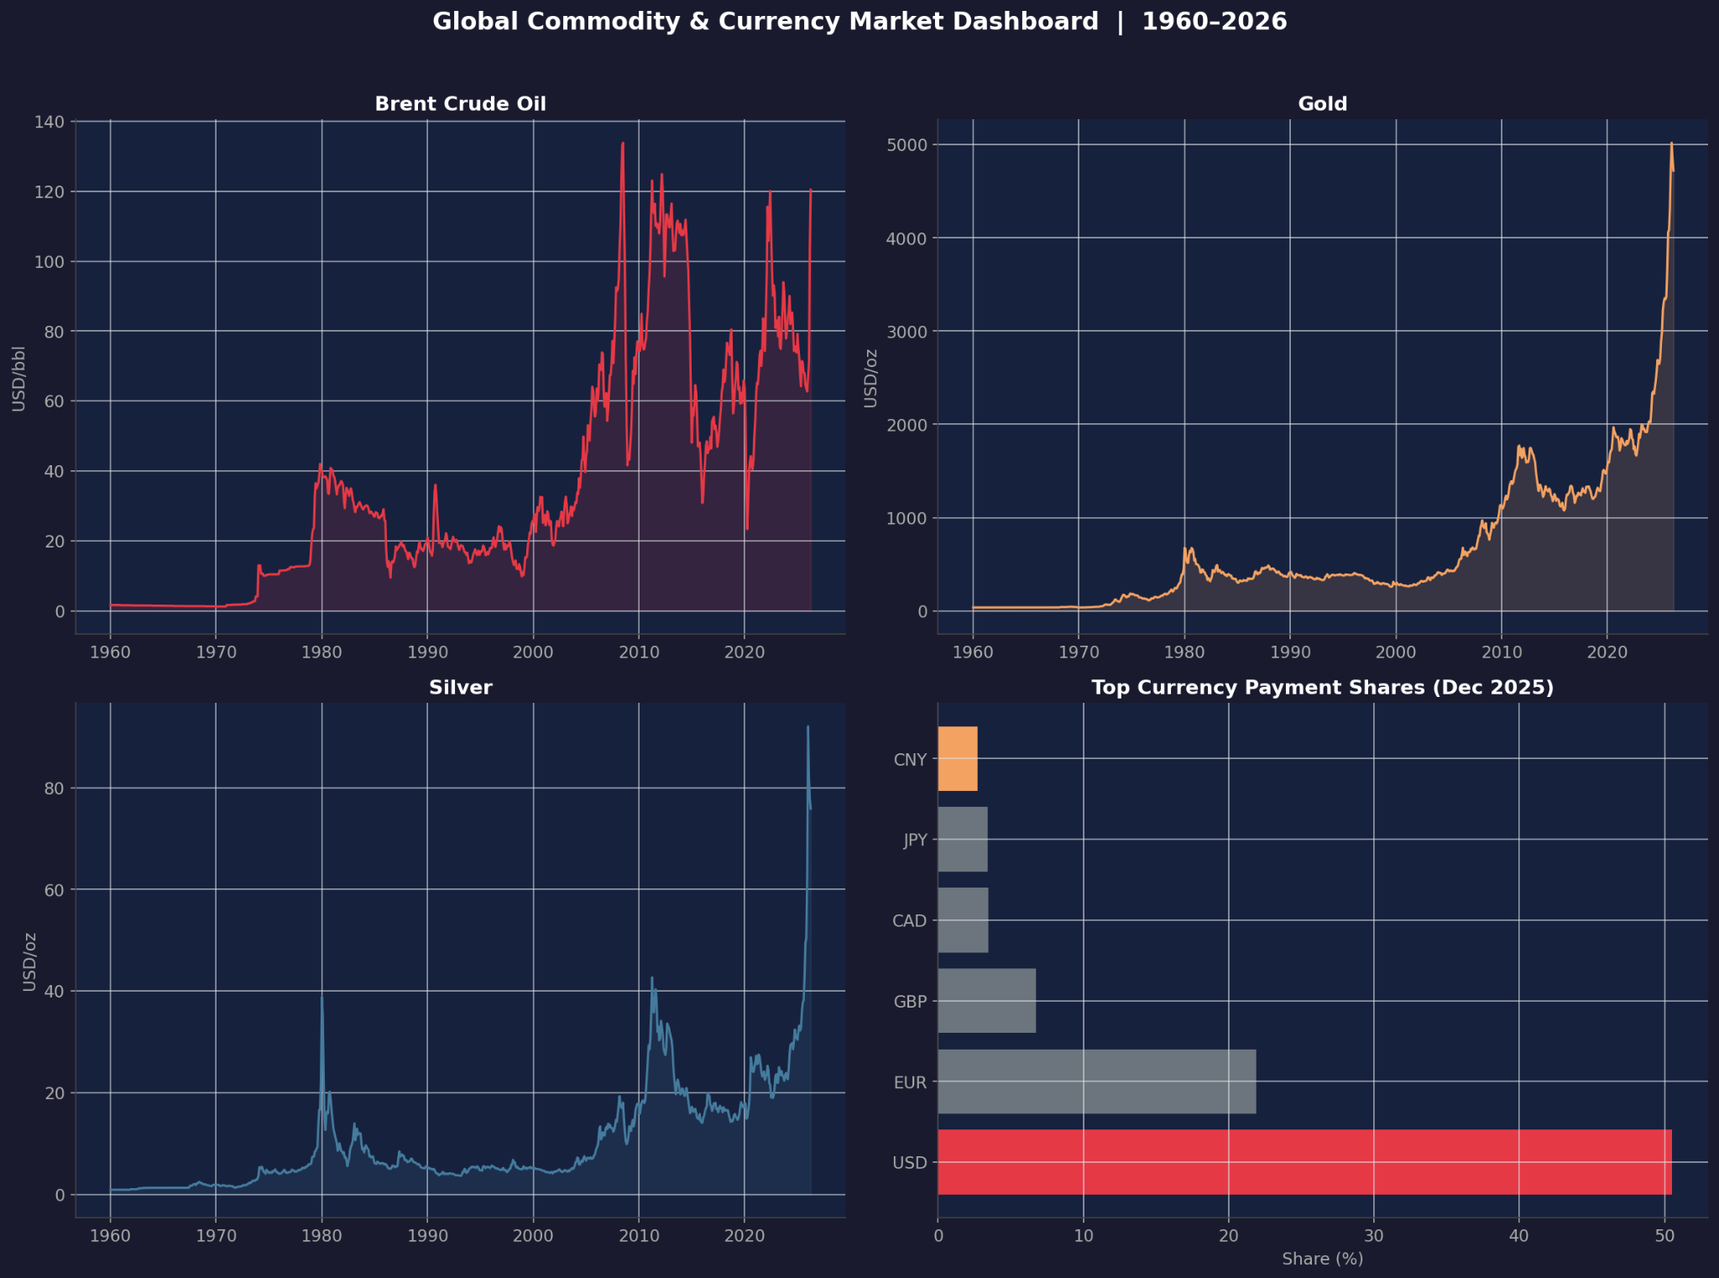
Figure A.1: Global Commodity & Currency Market Dashboard
The dashboard provides an integrated overview of commodity prices and global currency market indicators. It combines Brent Crude Oil, Gold, Silver, and currency payment share visualisations into a single interface, allowing users to monitor historical trends and compare key market indicators efficiently. This dashboard was developed to support interactive exploration of the analytical findings presented in the report.
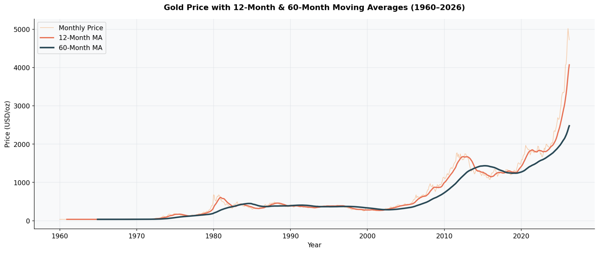Figure A.2: Gold Price with 12-Month and 60-Month Moving Averages (1960–2026)
This figure illustrates the monthly gold price together with its 12-month and 60-month moving averages. The moving averages smooth short-term price fluctuations and highlight the long-term trend, making it easier to identify sustained market movements, cyclical behaviour, and periods of significant price growth.
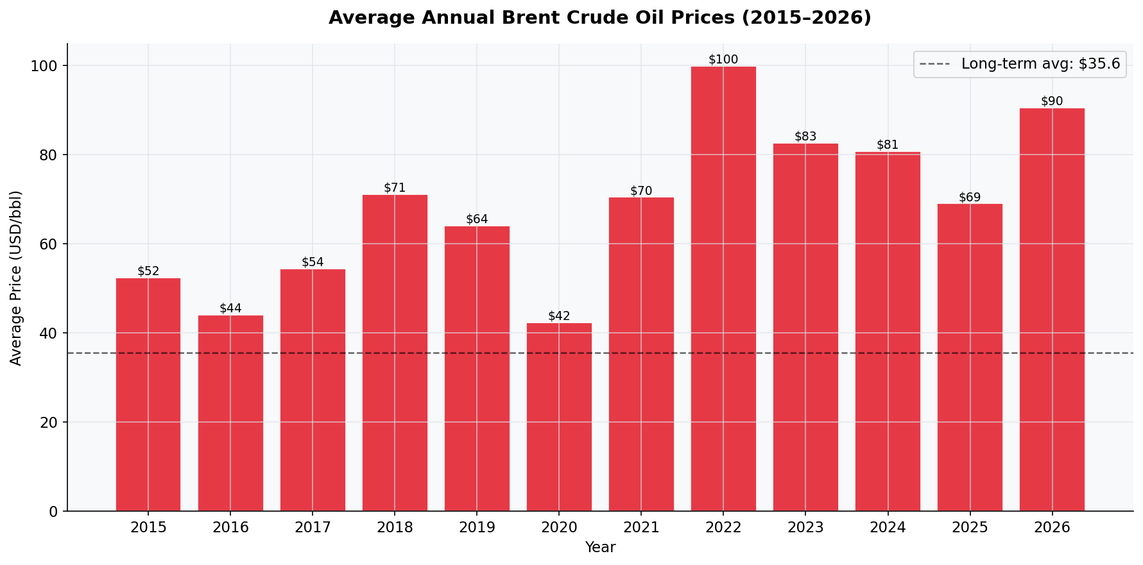Figure A.3: Average Annual Brent Crude Oil Prices (2015–2026)
This chart presents the annual average Brent Crude Oil prices from 2015 to 2026 together with the long-term average price. It provides a concise comparison of yearly price movements and highlights periods where oil prices were significantly above or below the historical average due to changes in global energy demand and geopolitical events.

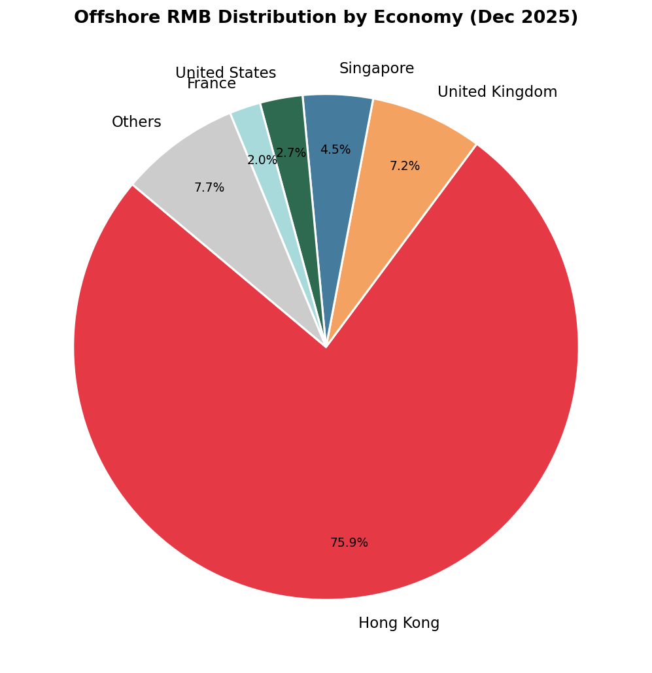
Figure A.4: Offshore RMB Distribution by Economy (December 2025)
This figure illustrates the geographical distribution of offshore Renminbi (RMB) activity across major economies. Hong Kong remains the dominant offshore RMB centre, accounting for approximately 75.9% of total offshore RMB transactions, followed by the United Kingdom and Singapore. The distribution highlights Hong Kong's critical role in facilitating international RMB settlement and cross-border financial activities.

Appendix B – Technical Details
Methodology Breakdown
The analysis presented in this report was performed using Python within a Jupyter Notebook environment. The workflow followed a structured data analytics process to ensure consistency, accuracy, and reproducibility of the results.
The analytical process included the following stages:
- Collection of historical commodity price and global currency market datasets from reliable public sources.
- Data cleaning and preprocessing, including handling missing values, formatting dates, and standardising variables.
- Exploratory Data Analysis (EDA) to identify trends, patterns, and anomalies.
- Statistical analysis using descriptive statistics, correlation analysis, and volatility assessment.
- Trend analysis of Brent Crude Oil, Gold, and Silver prices over the study period.
- Comparative analysis of commodity performance during major global economic and geopolitical events.
- Global currency market analysis using payment share, foreign exchange trading share, and foreign exchange reserve composition data.
- Development of visualisations and an interactive dashboard to support interpretation of the findings.
Software and Tools

Tool / Software | Purpose
Python | Data preprocessing, statistical analysis, and visualisation
Pandas | Data cleaning and manipulation
NumPy | Numerical computations
Matplotlib | Data visualisation
Jupyter Notebook | Analysis and documentation
Microsoft Excel | Data validation and summary tables

Python Notebook
The complete Python notebook containing the data preprocessing steps, statistical analysis, visualisations, and dashboard generation has been submitted as supplementary material for this project.
GitHub Repository:
https://github.com/JacobNicolus/DSB_Project
Jupyter Notebook:
The complete Jupyter Notebook containing the data preprocessing, exploratory data analysis, visualizations, and dashboard generation has been submitted as a separate file named Global_Commodity_Currency_Market_Analysis.ipynb.
Reproducibility Statement
The notebook includes all scripts required to reproduce the analyses presented in this report. The code follows a sequential workflow covering data import, preprocessing, exploratory data analysis, statistical computations, chart generation, and dashboard preparation, ensuring transparency and reproducibility of the results.

Appendix C – Glossary
Term | Definition
Brent Crude Oil | An internationally recognised benchmark for crude oil pricing, widely used to determine global oil prices.
Commodity | A basic raw material or primary agricultural product that can be bought, sold, and traded in financial markets.
Correlation | A statistical measure that indicates the strength and direction of the relationship between two variables.
Currency Composition of Official Foreign Exchange Reserves (COFER) | An International Monetary Fund (IMF) database that reports the composition of global official foreign exchange reserves by currency.
Foreign Exchange (Forex) Market | The global marketplace where currencies are traded and exchanged between governments, financial institutions, businesses, and investors.
Foreign Exchange Reserves | Foreign currencies and reserve assets held by central banks to support monetary policy, international trade, and financial stability.
Gold | A precious metal widely regarded as a safe-haven asset and commonly used as a store of value during periods of economic uncertainty.
Hedging | A financial risk management strategy used to reduce potential losses resulting from adverse movements in commodity prices or exchange rates.
Inflation | A sustained increase in the general price level of goods and services, reducing the purchasing power of money over time.
Moving Average | A statistical technique that smooths short-term fluctuations in data to identify long-term trends and patterns.
Renminbi (RMB) / Chinese Yuan (CNY) | The official currency of the People's Republic of China. The Renminbi (RMB) is the currency, while the Yuan (CNY) is its principal unit of account.
Safe-Haven Asset | An investment expected to retain or increase its value during periods of market uncertainty or economic instability. Gold is a common example.
Silver | A precious metal with both industrial applications and investment value, making its price sensitive to economic growth and market sentiment.
SWIFT | The Society for Worldwide Interbank Financial Telecommunication, a global financial messaging network used to facilitate secure international payment transactions.
Volatility | The degree of variation in the price of a financial asset over time. Higher volatility indicates greater price fluctuations and investment risk.

References
Bank for International Settlements. (2022). Triennial Central Bank Survey: Foreign exchange turnover in April 2022. Bank for International Settlements. https://www.bis.org/statistics/rpfx22.htm
Bank for International Settlements. (2024). Annual Economic Report 2024. Bank for International Settlements. https://www.bis.org/publ/arpdf/ar2024e.htm
International Monetary Fund. (2025). Currency Composition of Official Foreign Exchange Reserves (COFER). International Monetary Fund. https://data.imf.org/COFER
International Monetary Fund. (2025). World Economic Outlook Database. International Monetary Fund. https://www.imf.org/en/Publications/WEO
Macrotrends LLC. (2025). Brent crude oil prices – Historical annual data. https://www.macrotrends.net
Macrotrends LLC. (2025). Gold prices – Historical annual data. https://www.macrotrends.net
Macrotrends LLC. (2025). Silver prices – Historical annual data. https://www.macrotrends.net
Organisation for Economic Co-operation and Development. (2025). OECD Economic Outlook. OECD Publishing. https://www.oecd.org/economic-outlook/
Society for Worldwide Interbank Financial Telecommunication. (2025). RMB Tracker. https://www.swift.com/our-solutions/compliance-and-shared-services/business-intelligence/renminbi/rmb-tracker
U.S. Energy Information Administration. (2025). Brent spot price. https://www.eia.gov/dnav/pet/hist/LeafHandler.ashx?n=PET&s=RBRTE&f=A
World Bank. (2025). Commodity Markets Outlook. World Bank. https://www.worldbank.org/en/research/commodity-markets
World Gold Council. (2025). Goldhub: Gold prices and market insights. https://www.gold.org/goldhub
Harris, C. R., Millman, K. J., van der Walt, S. J., et al. (2020). Array programming with NumPy. Nature, 585(7825), 357–362. https://doi.org/10.1038/s41586-020-2649-2
Hunter, J. D. (2007). Matplotlib: A 2D graphics environment. Computing in Science & Engineering, 9(3), 90–95. https://doi.org/10.1109/MCSE.2007.55
McKinney, W. (2022). Python for data analysis (3rd ed.). O'Reilly Media.

